**Instance-1 (Read-only Storage Scope)**

1. Once you first log in, your screen should look similar to this.

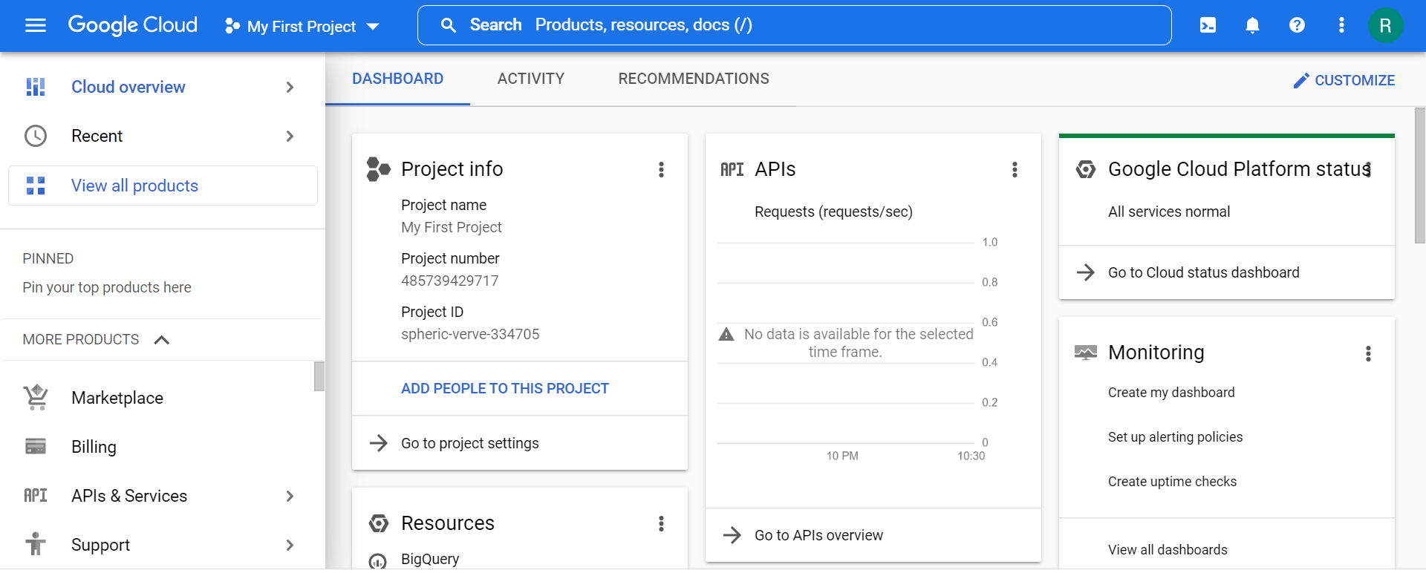

1. Click on the project selector drop-down menu at the top of the screen.

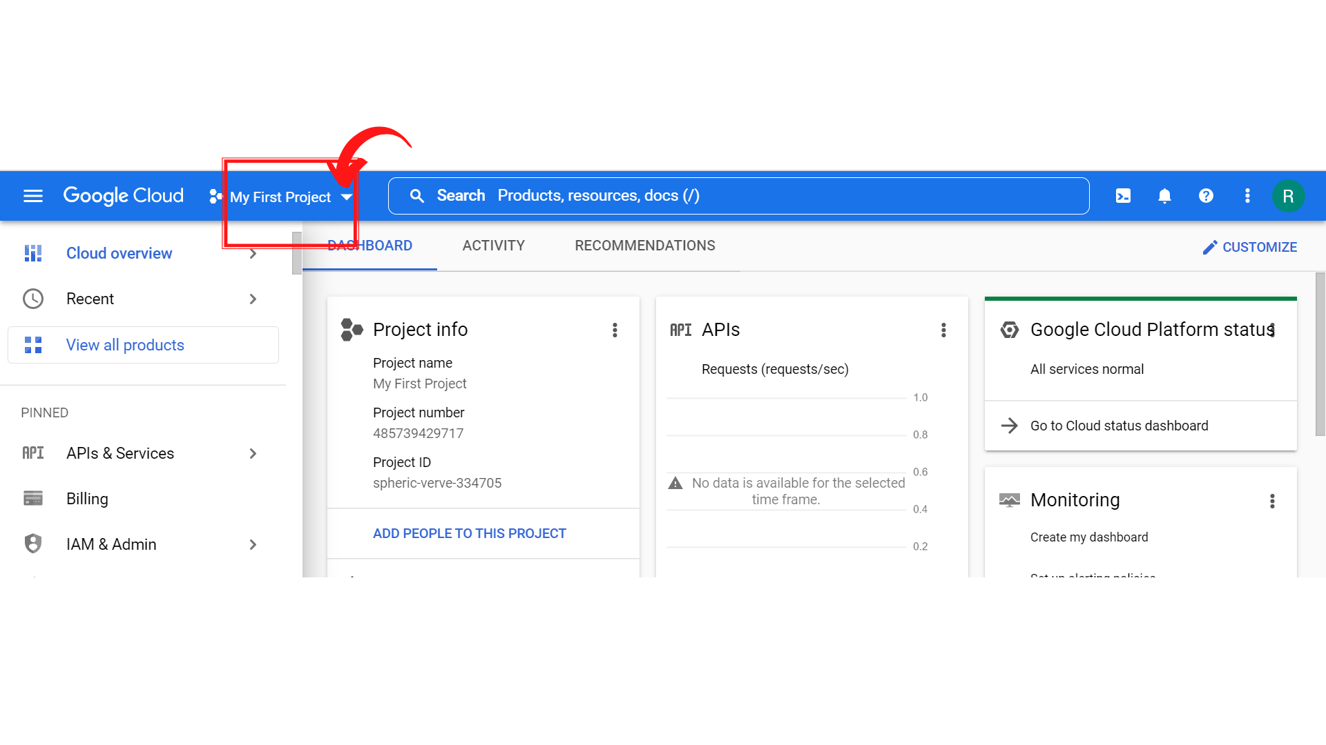

1. Since, we are doing labs on a Security Labs project, Click on *“Security Labs”*.

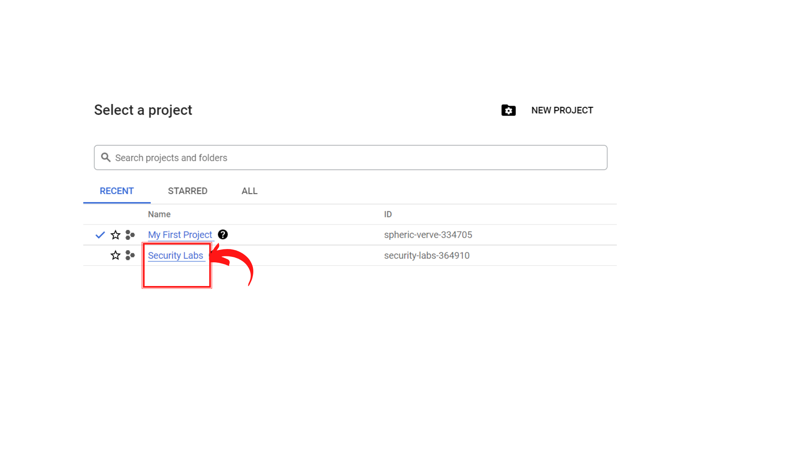

1. Your screen should look similar to this with project info changed to “*Security Labs”* project.

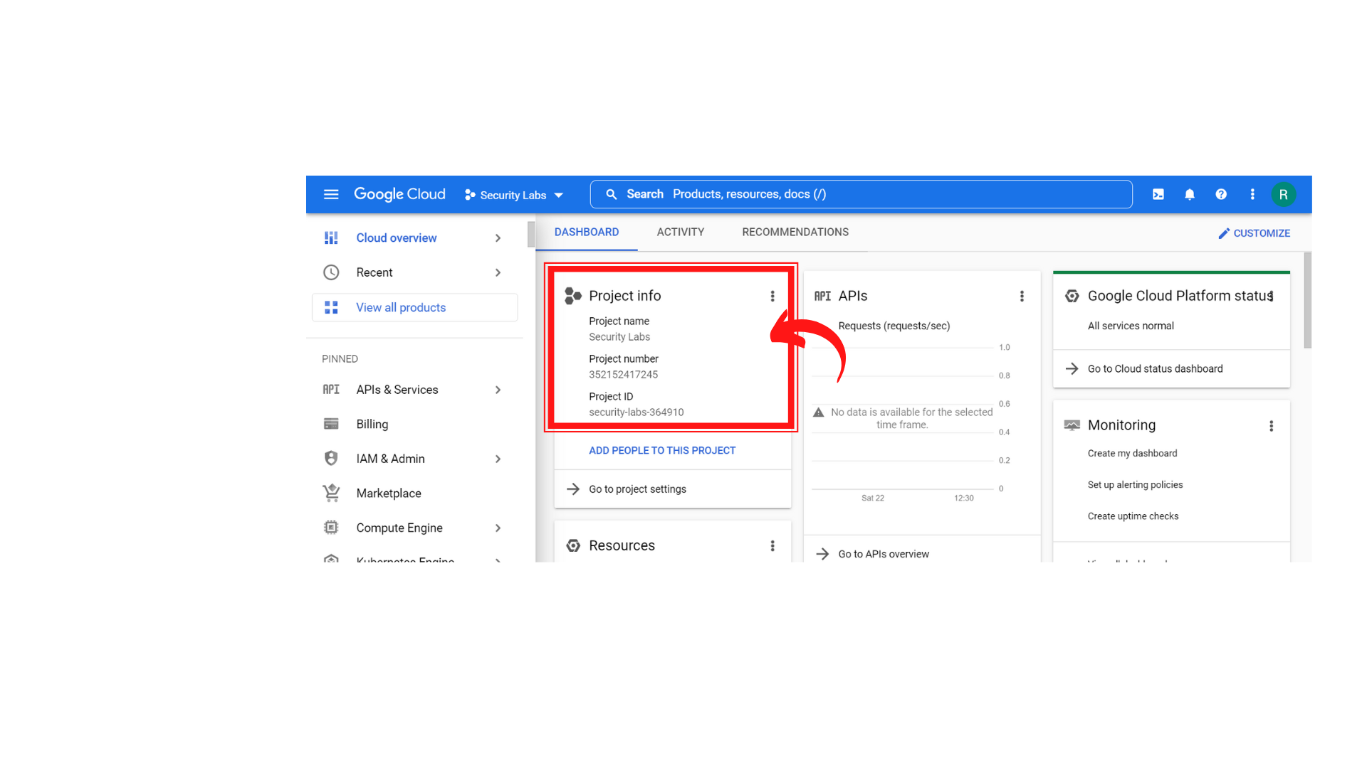

1. To create a new VM instance-1, click on *“Compute Engine → VM instances.”*

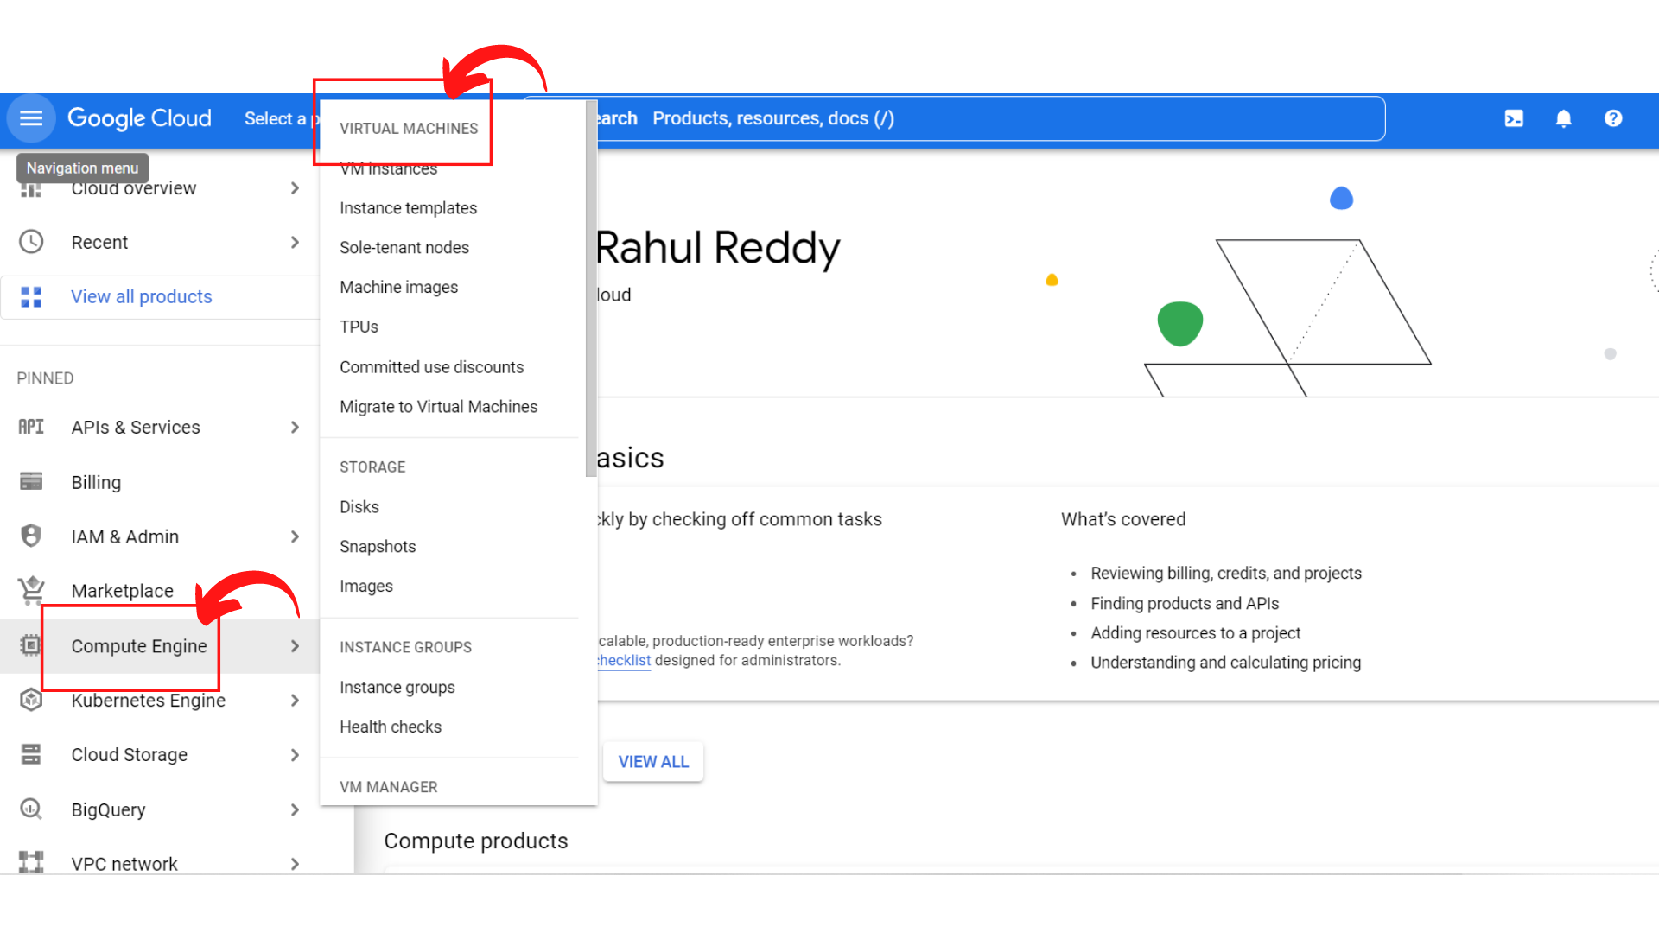

1. Your screen should look similar to this if your *“Compute Engine API”* is not enabled.

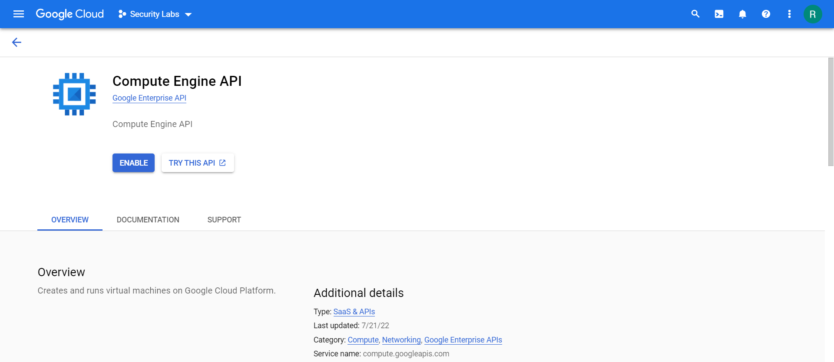

1. Click on *“Enable”*

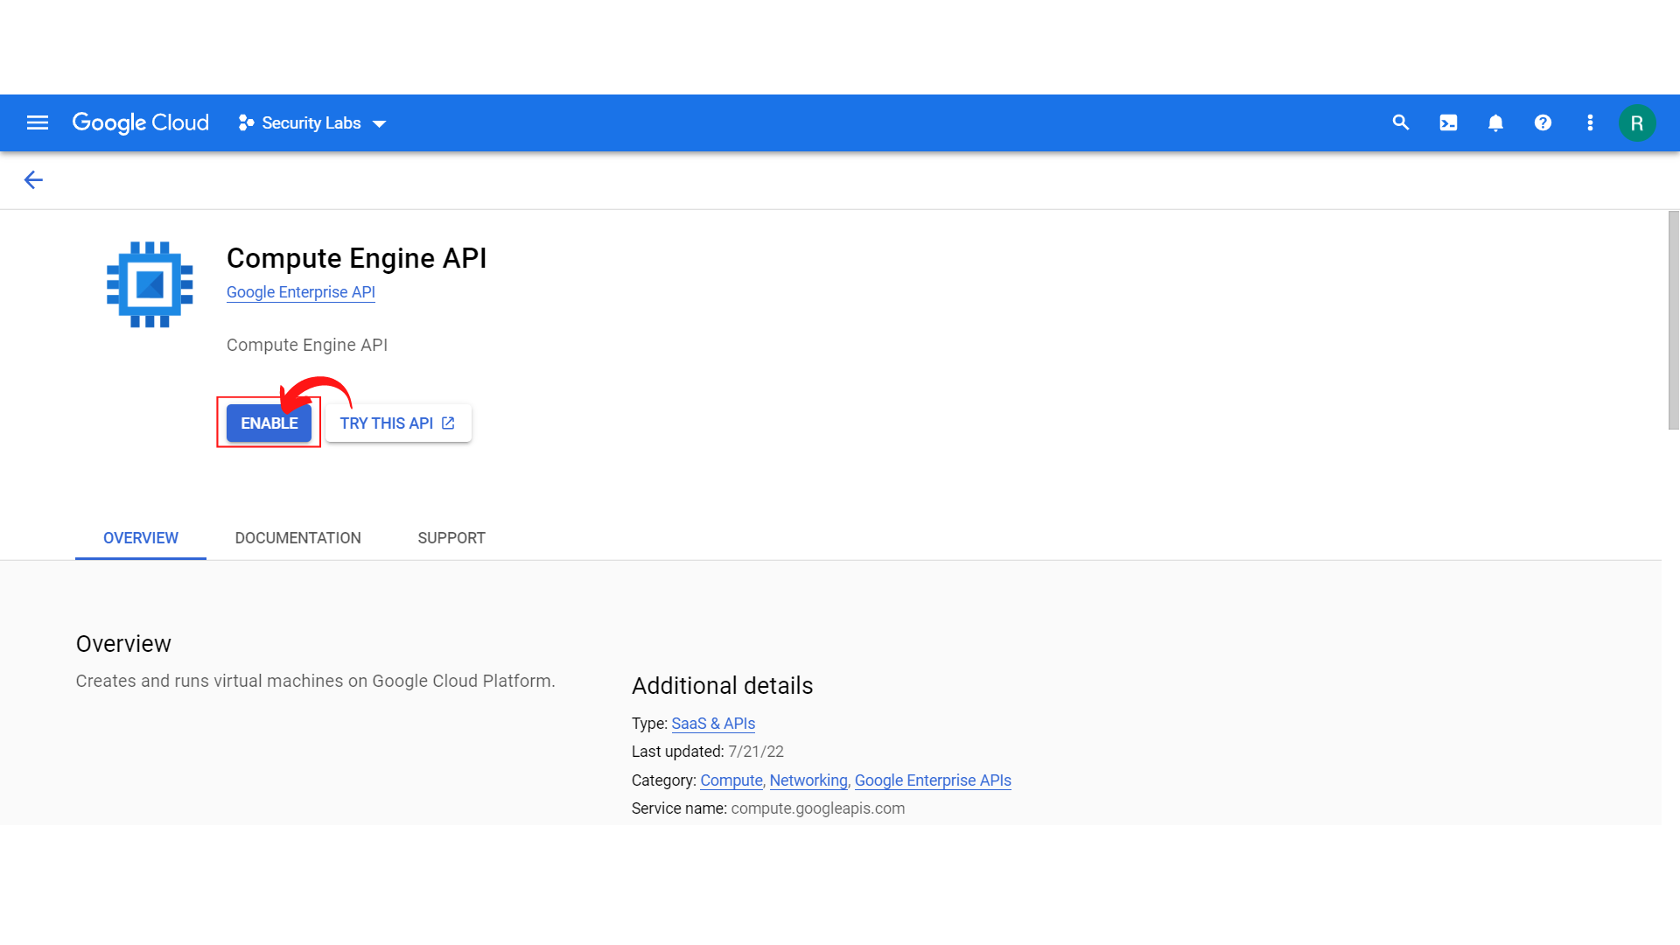

1. Once the Compute Engine API is enabled, your screen should look similar to this.

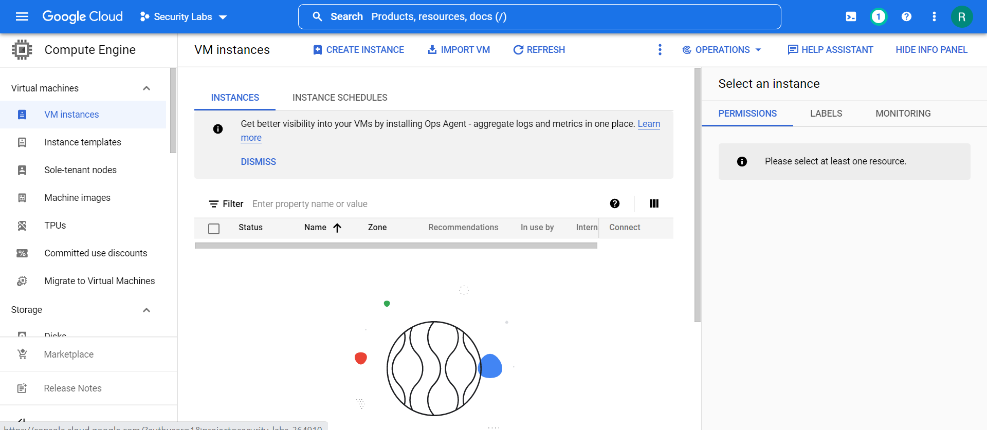

1. Click → “*Create Instance”*

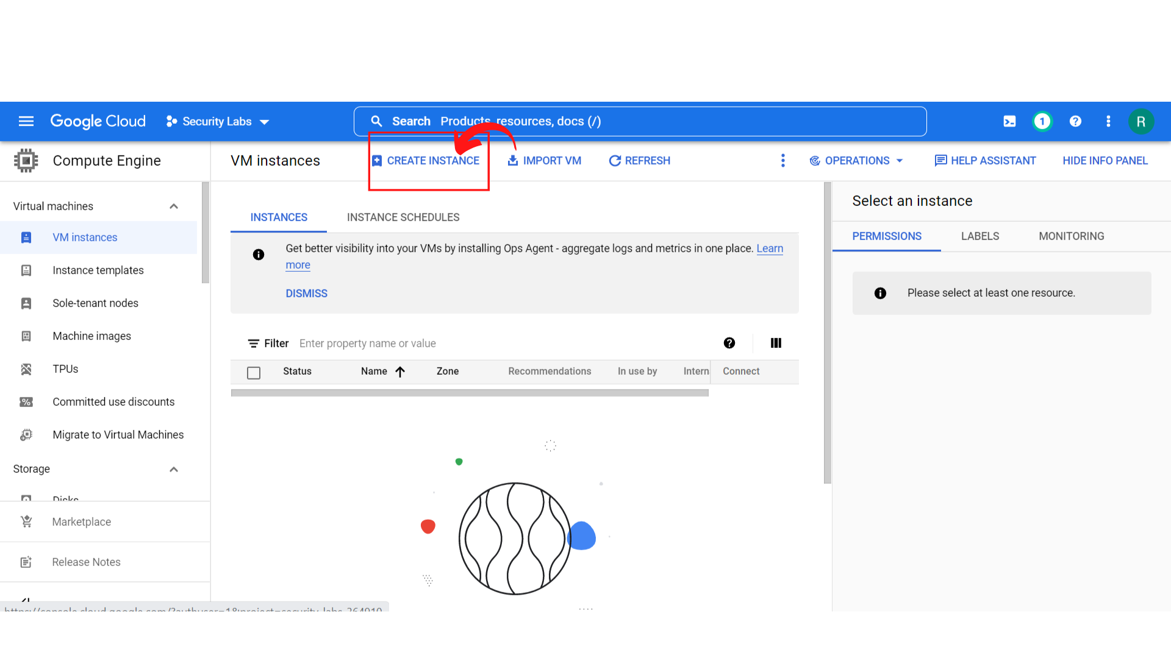

1. Your screen should look similar to this.

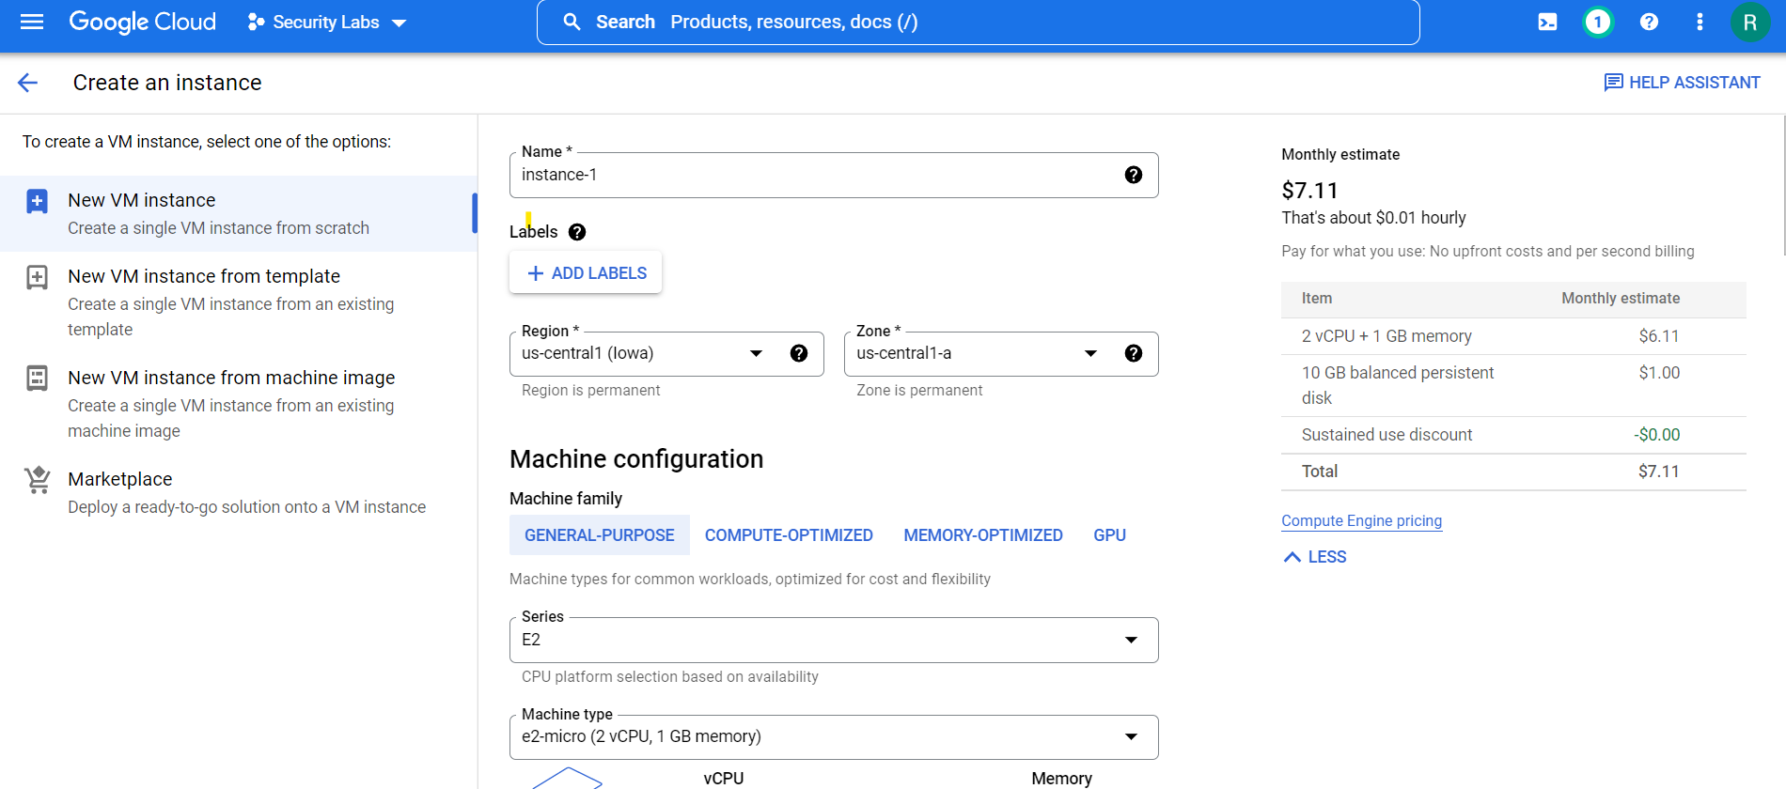

1. Enter the *Instance name as “****Instance-1”****, Add Labels* and *choose your Region and Zone correctly.*

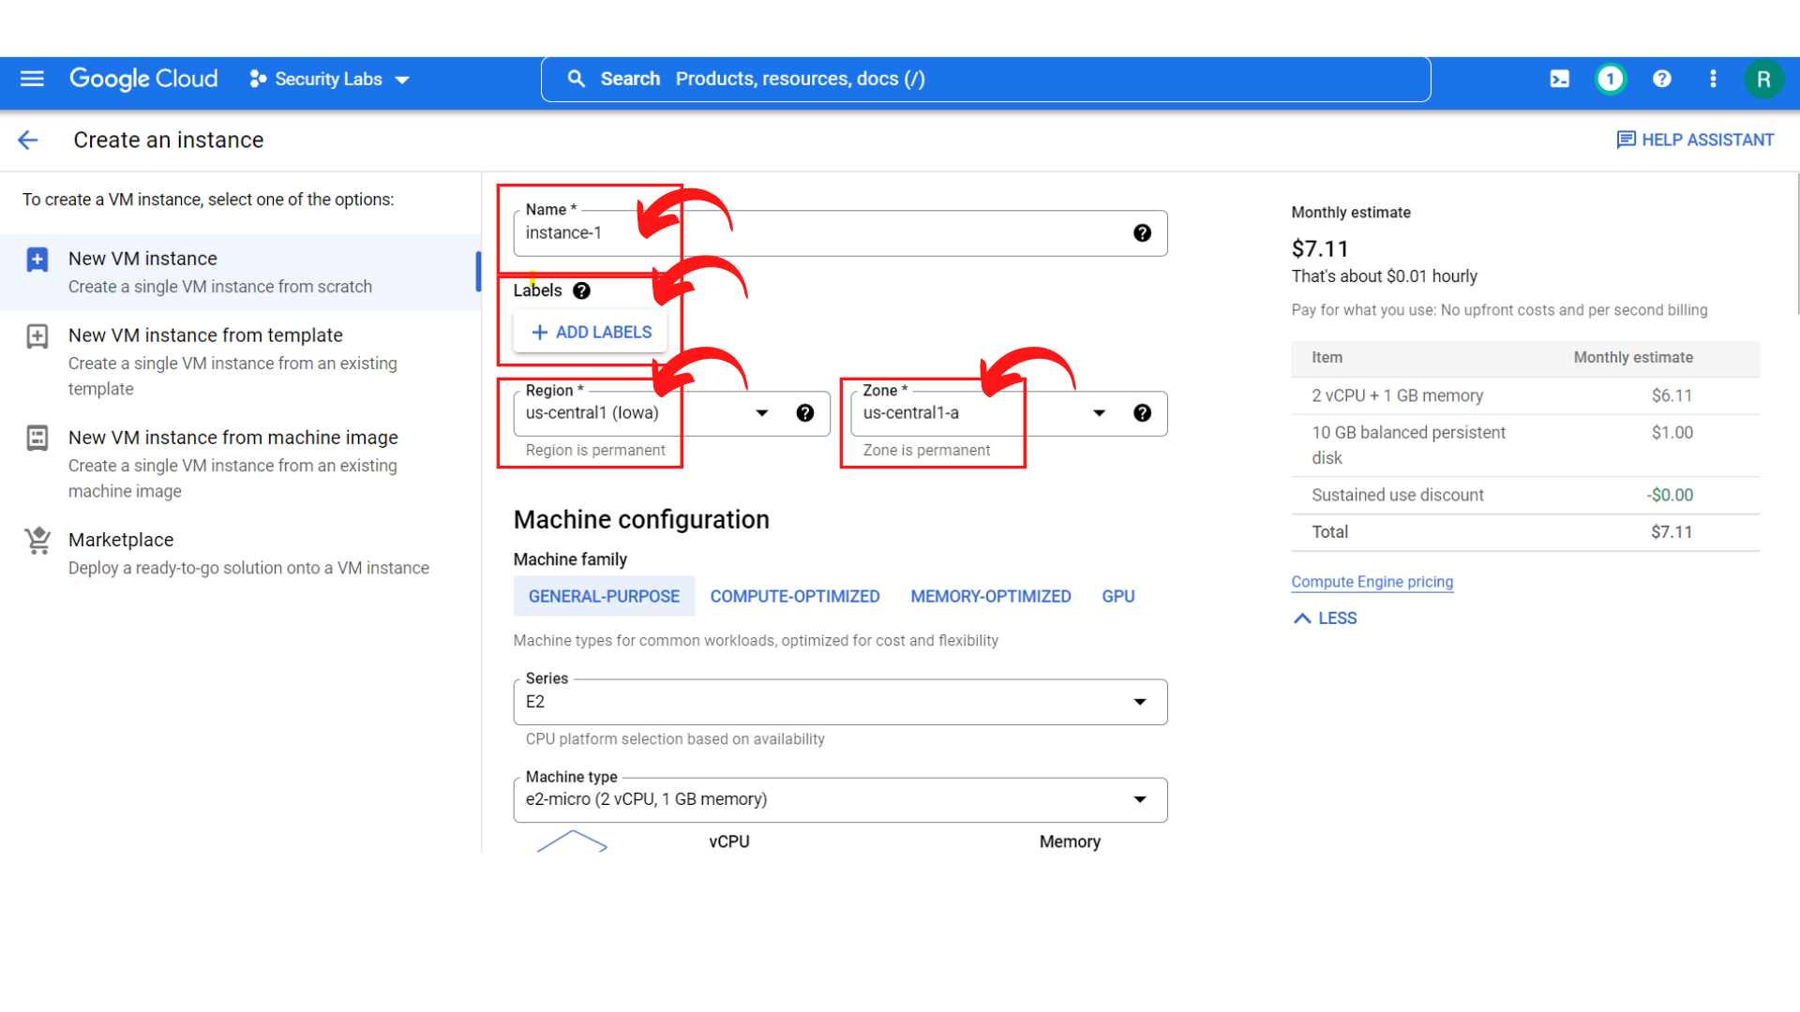

1. Now scroll down, you will see the *“Identity and API access” section*  where you can select your *service account*. Select ***“Compute Engine default service account”***

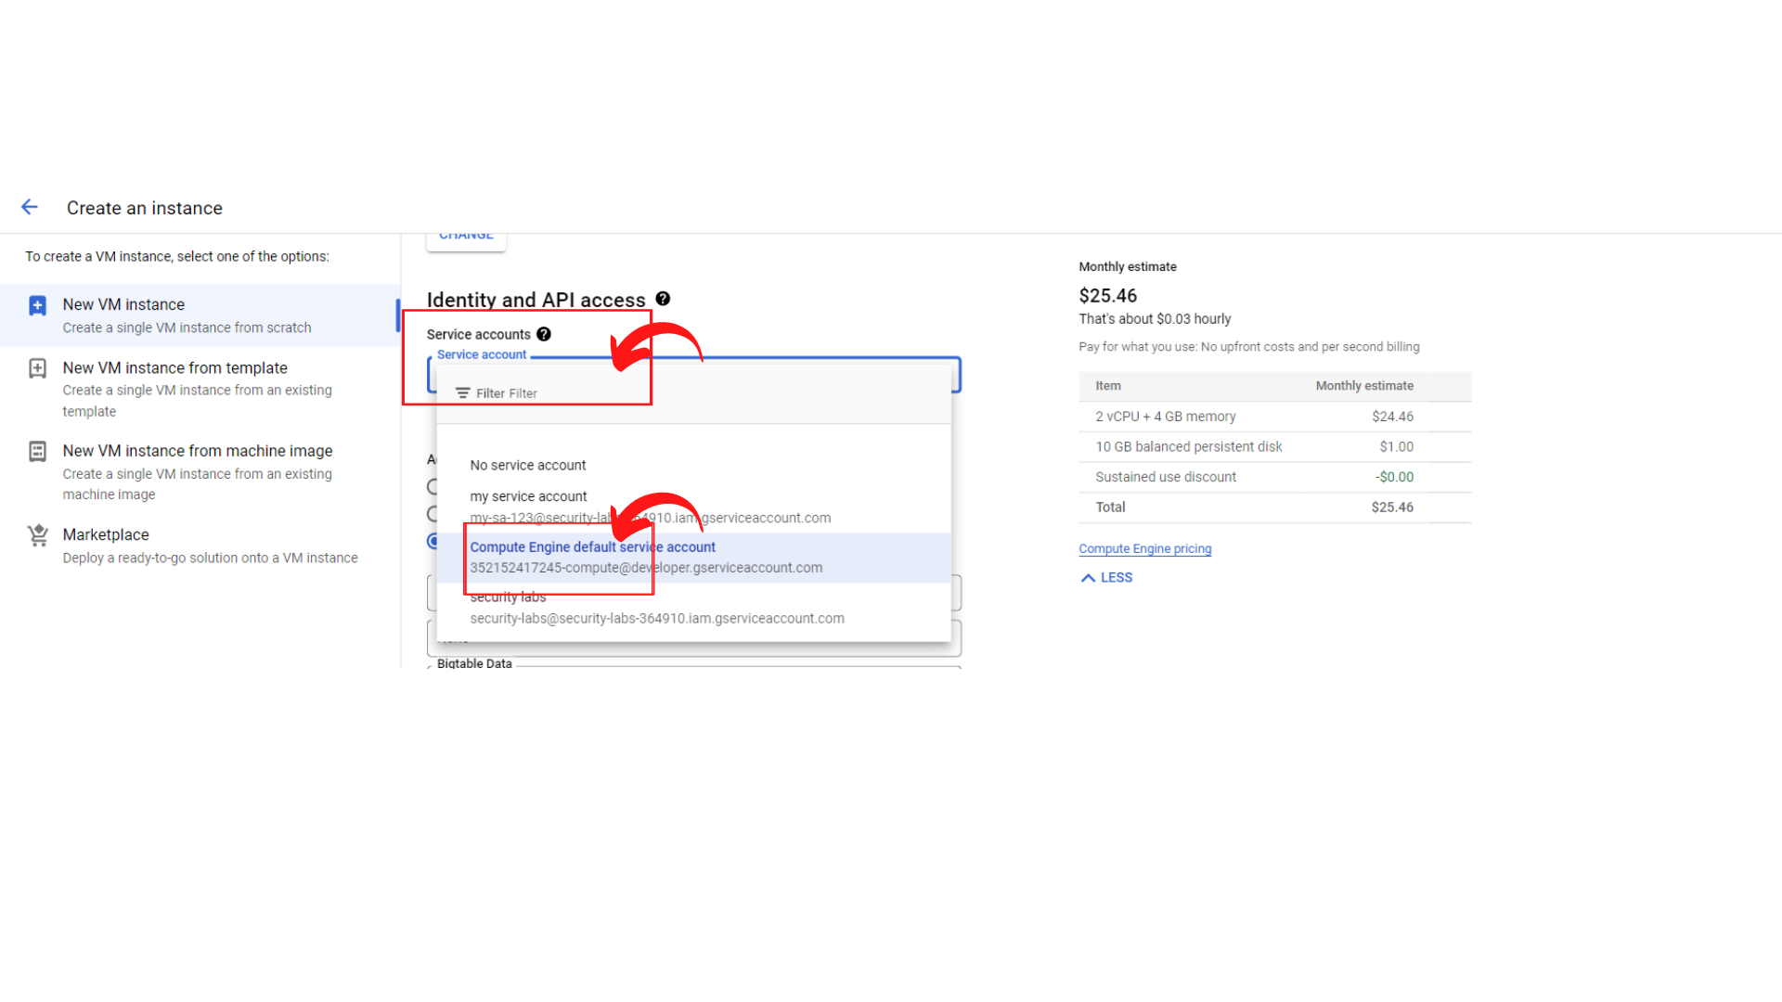

1. Under the “Access Scopes” section, where you can Select the type and level of API access to grant the VM. Select ***“Set access for each API and scroll down to see Storage(Read-only)***

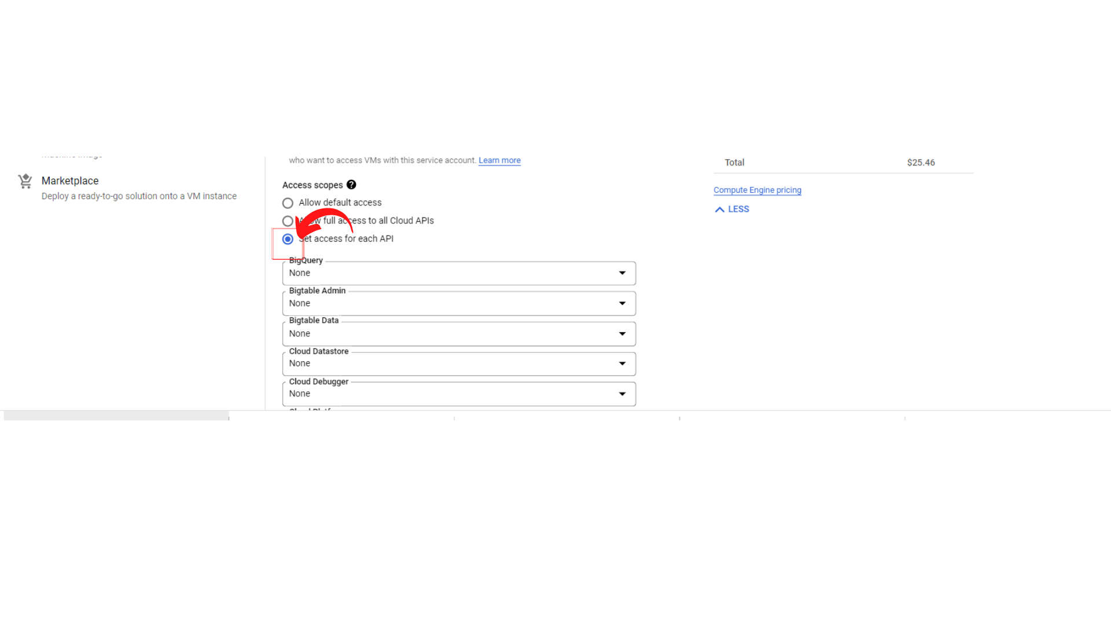

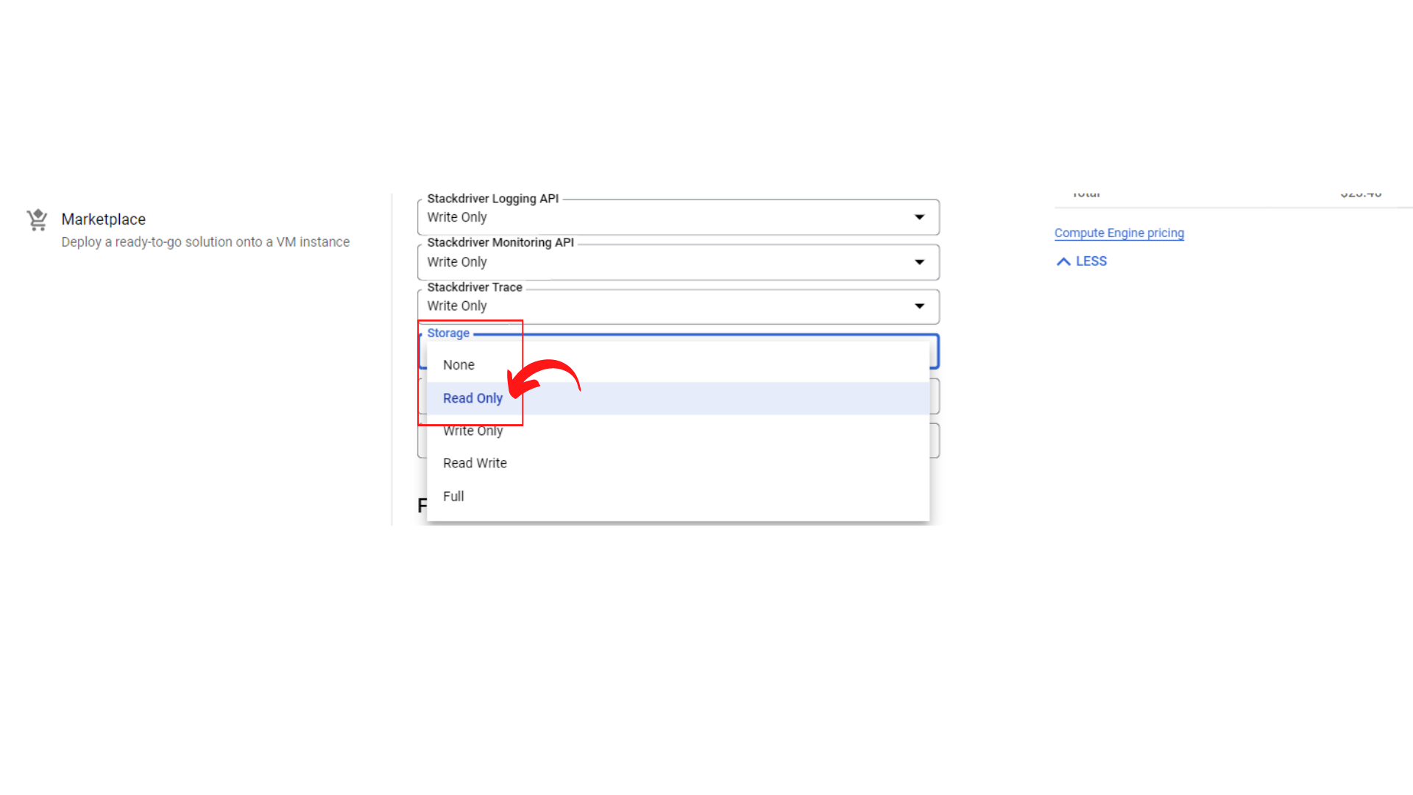

**Note: Please select Read Only for Storage.**

1. Now scroll down, and click on the *“Create”* button.

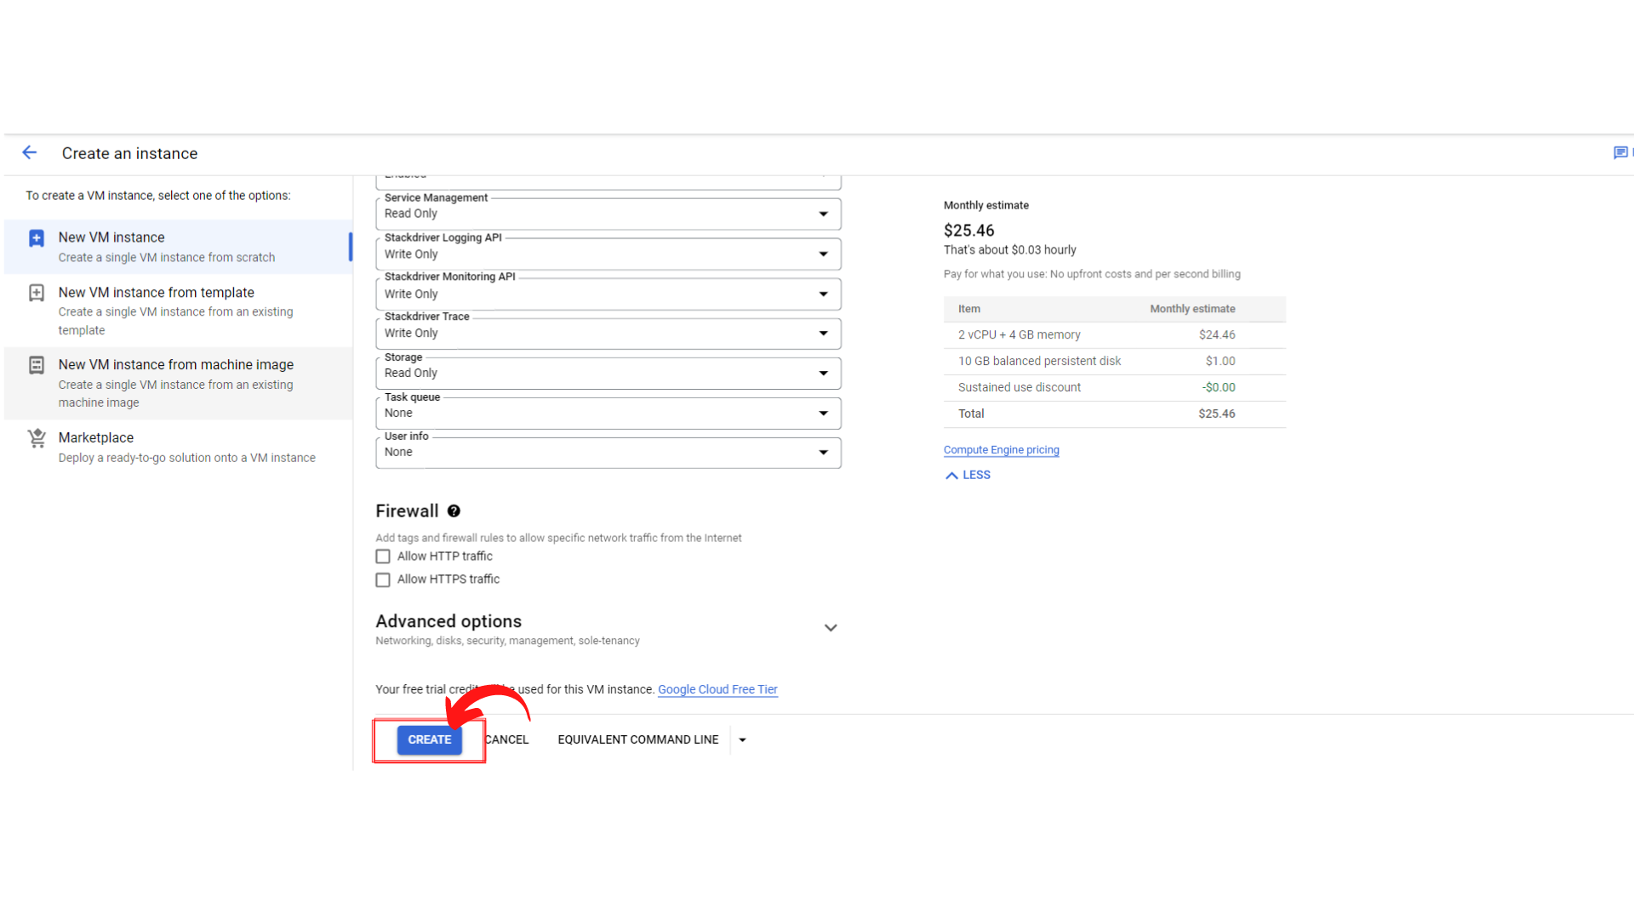

1. Now your screen should look like this with *status → “Green Color Tick Mark”.* That means your instance is running.

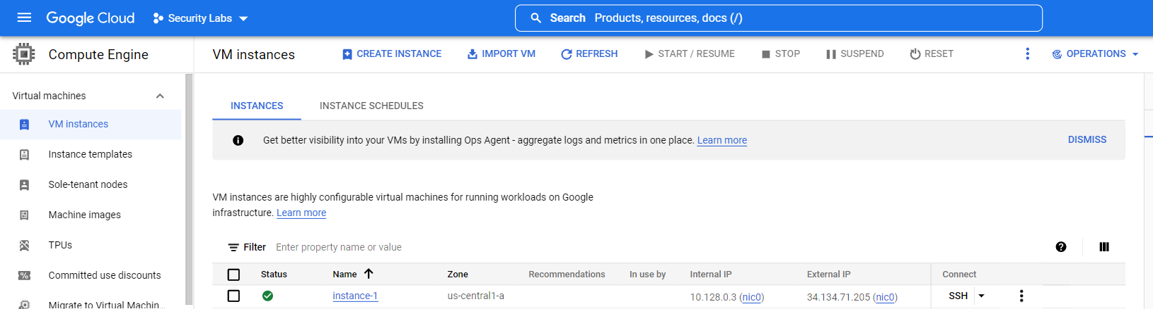

That’s it, you have successfully created your instance-1 with Read-only Storage Scope on GCP.